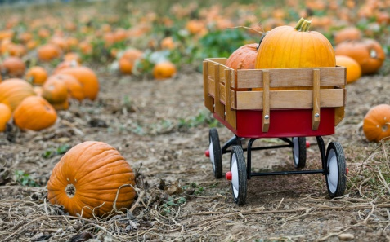sf7_banner3C:\Program Files (x86)\Microsoft Office\MEDIA\CAGCAT10\j0285698.wmfC:\Program Files (x86)\Microsoft Office\MEDIA\CAGCAT10\j0199036.wmfsf7_banner3

Due to our shortened week next week, we will not have a weekly list of spelling words. This would be a great time to review words that contain the short vowel /a/, such as mat, cat, map, ran and ham; as well as words that contain the short vowel /i/, such as pig, lip, rim, fin and did.

**Spelling:** Students will review spelling words which contain the short vowels /a/ and /i/.

**Reading:** Students will review reading words which contain the short vowels /a/ and /i/. Due to our shortened week, we will not have a weekly homework packet.

**Math:** We will complete our unit focused on subtraction strategies from 10.

**Science:** We will finish our unit on

pumpkins, and on Wednesday, we will

go on our first field trip to the

pumpkin patch!

the of you

and to

Weekly Heart Words

Weekly Spelling Words

**This Week’s Spelling Words**



***Each Friday, your child will bring home a letter containing information about First Grade. It will be in their green homework folder. Please read over the information carefully.***

News and Notes from Mrs. Hogan’s Classroom

Week of October 10 – October 14



This week we have focused a great deal on pumpkins. Students are learning about the pumpkin life cycle and parts of a pumpkin to prepare for our upcoming field trip to the pumpkin patch.

◻ Monday, 10/10 – Hat Day

◻ Tuesday, 10/11 – Pajama Day

◻ Wednesday, 10/12 – Spartan/Camo Day

◻ Wednesday, 10/12 – Pumpkin Patch Field Trip (Don’t forget a packed lunch!)

◻ Thursday, 10/13 – No School (Teacher Workday/Parent-Teacher Conferences)

◻ Friday, 10/14 – No School (Parent-Teacher Conferences/Teacher Workday)

◻ Friday, 10/28 – End of 1st nine weeks

◻ Monday, 10/31 – Halloween Carnival (Students are allowed – and encouraged in my class- to dress up for Halloween. Masks and weapons are not allowed)

**Tablets** - Please be sure your child brings their charged tablet to school each day. Tablets will be used daily in our classrooms once reading groups begin.

**Water Bottle** - Please be sure to send in a water bottle with your child daily.



**October Reading Log** – October reading logs will be sent home on Monday. Each time you read a story with your child, please allow your child to color one of the “candy corns” on this log. Once all candy corns are colored, students will be allowed to choose a book from our classroom library to keep as their own at home. **Please keep this log tapped to the folder, as I will check it each day.**

**Library Books** – As a reminder, all library books will be collected each Monday morning. This will give Mrs. Corboy time to check books in by our library time on Tuesday.

**Field Trip** – First Graders will go on their first field Trip Wednesday, October 12th to the pumpkin patch at Joe’s Tree Farm. I will send a brown paper bag home on Monday. Please be sure to pack student lunches in this bag for the field trip, as anything left will need to be thrown away before leaving.

**Popcorn Fridays**- Please be sure to send in either $1.00 for popcorn or a snack for your child to enjoy during an afternoon movie.

Due to our shortened week, we will not have a weekly homework packet.

[jhogan@gilesk12.net](mailto:jhogan@gilesk12.net)

<http://mrshogan1.weebly.com/>

Dates to Remember



Here’s what we’ve been doing...

All Star Kids can do

2

