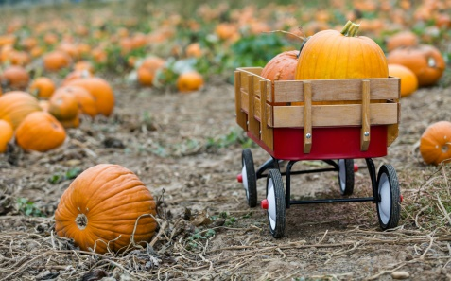sf7_banner3C:\Program Files (x86)\Microsoft Office\MEDIA\CAGCAT10\j0285698.wmfC:\Program Files (x86)\Microsoft Office\MEDIA\CAGCAT10\j0199036.wmfsf7_banner3

**Spelling:** Students will focus on spelling words which contain the short vowels /a/ and /i/.

**Reading:** We will focus on reading and spelling nonsense words that contain the short /a/, short /i/, and the letters f, d, and r. We will continue to blend words and focus on reading phrases and sentences.

**Math:** We will continue to focus on subtraction from 10. We will use manipulatives such as counters, blocks and our fingers to help us subtract.

**Science:** We will begin our unit on

pumpkins to prepare for our upcoming

field trip to the pumpkin patch!

Students will learn about the life

cycle of a pumpkin, pumpkin parts,

and where a pumpkin grows.

the of you

and to

Weekly Heart Words

1. mad 5. dad 9. fast

2. if 6. sift 10. fist

3. hat 7. last

4. lad 8. raft

Weekly Spelling Words

**This Week’s Spelling Words**



***Each Friday, your child will bring home a letter containing information about First Grade. It will be in their green homework folder. Please read over the information carefully.***

News and Notes from Mrs. Hogan’s Classroom

Week of October 3 – October 7



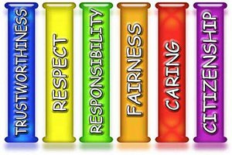

Congratulations to **Stella Dowdy** for being chosen as our first “Student of the Month”. Each month, a new student will be chosen from our classroom. I will be looking for a student who follows directions, and demonstrates behaviors from each of Eastern’s character pillars pictured to the right

**Fall Trees** – This week, we used fingerpaints and fruit loops to show fall leaves changing colors. Be sure to check out our class website at <https://mrshogan1.weebly.com/>.



◻ Wednesday, 10/12 – Pumpkin Patch Field Trip

◻ Thursday, 10/13 – No School (Teacher Workday/Parent-Teacher Conferences)

◻ Friday, 10/14 – No School (Parent-Teacher Conferences/Teacher Workday)

◻ Friday, 10/28 – End of 1st nine weeks

◻ Monday, 10/31 – Halloween Carnival (Students are allowed – and encouraged in my class- to dress up for Halloween. Masks and weapons are not allowed)

**Tablets** - Please be sure your child brings their charged tablet to school each day. Tablets will be used daily in our classrooms once reading groups begin.

**Water Bottle** - Please be sure to send in a water bottle with your child daily.

**October Reading Log** – October reading logs will be sent home on Monday. Each time you read a story with your child, please allow your child to color one of the “candy corns” on this log. Once all candy corns are colored, students will be allowed to choose a book from our classroom library to keep as their own at home. **Please keep this log tapped to the folder, as I will check it each day.**

**Library Books** – As a reminder, all library books will be collected each Monday morning. This will give Mrs. Corboy time to check books in by our library time on Tuesday.

**Field Trip** – First Graders will go on their first field Trip Wednesday, October 12th to the pumpkin patch at Joe’s Tree Farm. Field Trip forms were sent home on Wednesday. If you have not returned this form, please do so as soon as possible.

**Popcorn Fridays**- Please be sure to send in either $1.00 for popcorn or a snack for your child to enjoy during an afternoon movie.

[jhogan@gilesk12.net](mailto:jhogan@gilesk12.net)

<http://mrshogan1.weebly.com/>

Dates to Remember



Here’s what we’ve been doing...

All Star Kids can do

2

